BAC.ACAD.PM.03.F02.V2.0

Appendix 1: Assignment submission cover sheet

ASSIGNMENT SUBMISSION COVER SHEET

Student Id: CSE24-023

Student names: TLAMELO KYLIE JORI

Student email: CSE24-023 @thuto.bac.ac.bw

Cohort: CSE24

Assignment title: OOAD IN JAVA SYSTEM DOCUMENTATION

Date of submission: 19/09/2025

Programme of Study: COMPUTER SYSTEMS ENGINEERING

Year of Study: 2025

Intellectual property statement

By checking the box below, I certify that this assignment is my own work and is free from

plagiarism. I understand that the assignment may be checked for plagiarism by

electronic or other means and may be transferred and stored in a database for the

purposes of data-matching to help detect plagiarism. The assignment has not previously

been submitted for assessment in any other unit or to any other institution. I

have read and understood the Botswana Accountancy College plagiarism guidelines

policy.

☐ Agree Signature……………T.K.JORI……………………….

Date…………19/09/2025……………………………….

**FUNCTIONAL REQUIREMENTS**

**Transaction Processing**

**Pay Interest**: The system shall automatically apply the correct monthly interest rate (5% for Investment, 0.05% for Savings) to customer accounts.

**Withdraw:** The system shall process withdrawals only from permitted account types (investment and cheque )if sufficient funds exist, decreasing the balance.

**System Security**

**Login:** The system shall require valid credentials to access any functionality, preventing unauthorized use.

**Customer Management**

**Account Opening**: The system shall allow the creation of a new customer profile by capturing essential personal details.

Account Management

**Open Account**: The system shall allow a bank employee to create a new account (savings, investment or cheque) for an existing customer.

**NON-FUNCTIONAL Requirements**

**Security**

The system must protect customer data and transactions from unauthorized access.

**Performance**

The system should respond to user actions (like login, deposit, withdraw) within a short period of time.

**Usability**

The system should be simple and easy to use, with clear instructions on the interface.

**Reliability**

The system should always record transactions correctly and not lose data.

**Maintainability**

The system should be easy to update, adhering to OOAD principles for simple future maintenance and expansion.

STRUCTURAL UML MODELLING

System Use Case Diagram

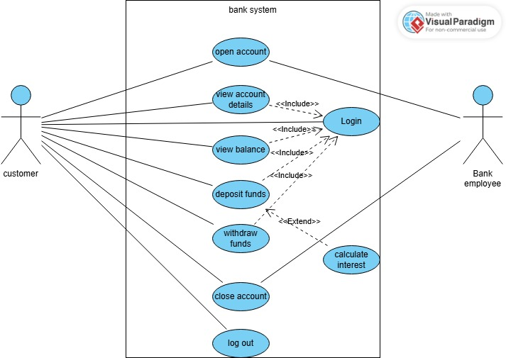

Class Diagram

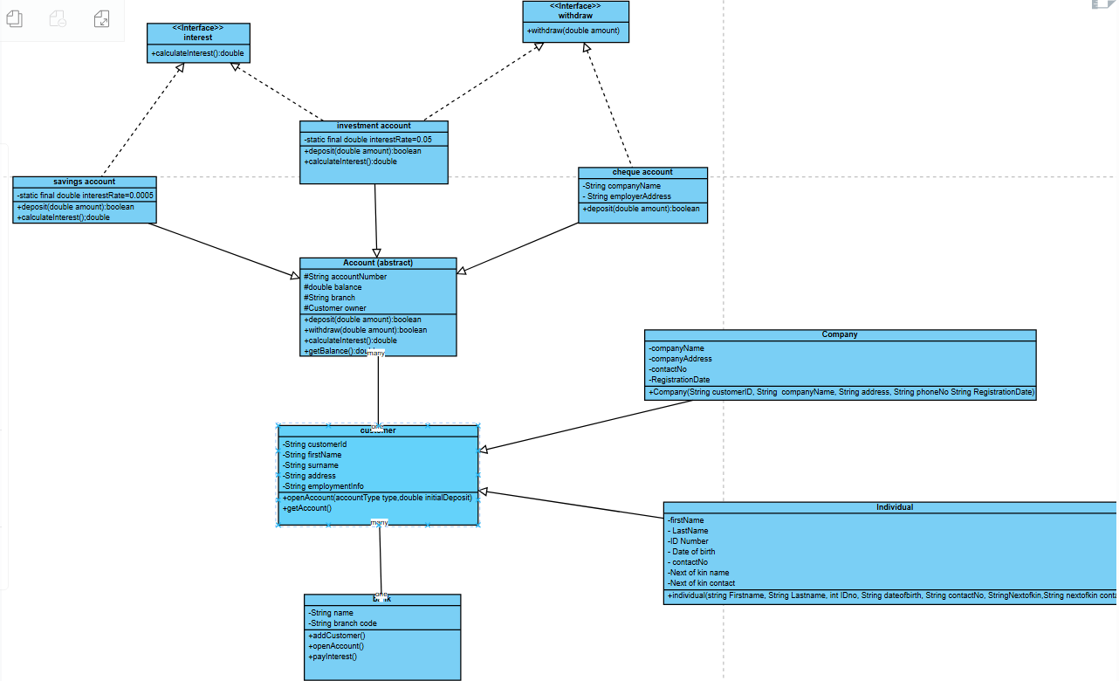

**Sequence Diagrams**

1. Deposit sequence diagram

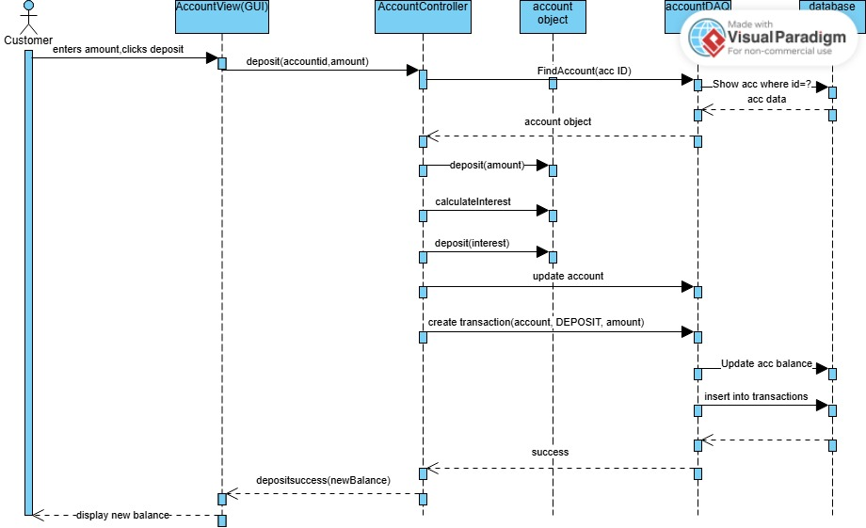

2.Login sequence diagram

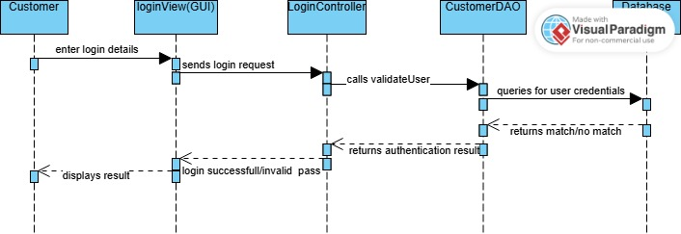

State Diagram

**SYSTEM DOCUMENTATION**

**MOCK INTERVIEW RECORD**

**Interview Title**: SYSTEM’S FUCTIONAL REQUIREMENTS

**Interviewer**: MS TLAMELO KYLIE JORI

**Interviewee** (client):MR KENTSENAO BASEKI

**Interview Date**:18/09/2025

**Interview Time**:1030-1130

**Interview Location:** ONLINE MEETING

**QUESTIONS ASKED AND THEIR RESPONSES**

**1.Interviewer:** Can a single customer own multiple types of accounts?

**Interviewee:** Yes, a customer can own all 3 types of accounts (savings, cheque and investment account).

**2.Interviewer**: What happens when a customer tries to deposit less than the required amount?

**Interviewee:** The system will show an error and will not accept any amount less than 500pula.

**3.Interviewer:** What customer details are captured during account opening?

**Interviewee:** It depends which customer it is, if it’s an individual, details like first name, date of birth, address and ID are captured and if it’s a company details like company name, company address, date of incorporation and business registration date are captured.

**4. Interviewer:** Are customers registered before opening accounts?

**Interviewee:** NO, Customers are not registered, the fact that an account is open means the customer is in the system.

**5.Interviewer:** What types of transactions can be performed in the system?

**Interviewee:** Deposit, withdrawal and interest payment.

**6.Interviewer:** What happens when you want to close your account, but it has money inside?

**Interviewee:** The bank will return your remaining balance before closing the account

THANK YOU!!!